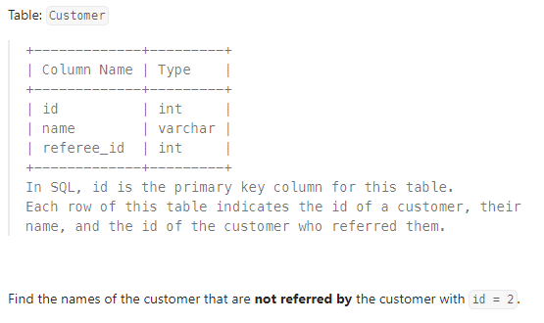

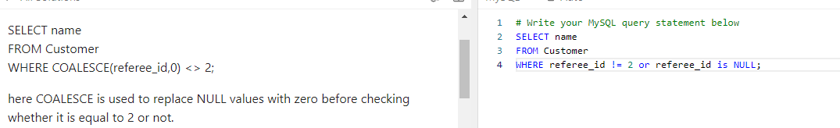

4. article views 1

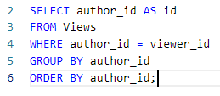

Same as

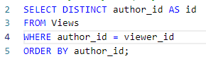

Because

GROUP BY author_id: Groups the results by author_id. Since there's no aggregate function, this effectively results in unique author_id values.

5.

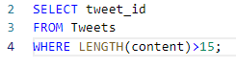

CTE (Common Table Expression) vs Views

<https://minhngocda.medium.com/view-vs-cte-in-sql-difference-and-use-cases-227307d0d672>

Qs

Does the changes made in the main table be reflected in views

If views are just queries stored then how come we can update views

**Rules to Update Views in SQL:**

Certain conditions need to be satisfied to update a view. If any of these conditions are **not** met, the view can not be updated.

1. The SELECT statement which is used to create the view should not include GROUP BY clause or ORDER BY clause.
2. The SELECT statement should not have the DISTINCT keyword.
3. The View should have all NOT NULL values.
4. The view should not be created using nested queries or complex queries.
5. The view should be created from a single table. If the view is created using multiple tables then we will not be allowed to update the view.

If a view made by using joins needs to be updated:

Some databases support INSTEAD OF triggers, which can make complex views updatable by defining what should happen when an INSERT, UPDATE, or DELETE is performed on the view. For example:

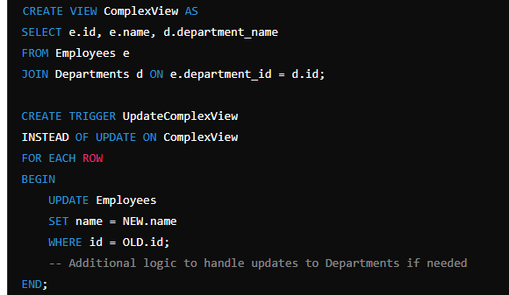

CREATE VIEW ComplexView AS

SELECT e.id, e.name, d.department_name

FROM Employees e

JOIN Departments d ON e.department_id = d.id;

CREATE TRIGGER UpdateComplexView

INSTEAD OF UPDATE ON ComplexView

FOR EACH ROW

BEGIN

UPDATE Employees

SET name = NEW.name

WHERE id = OLD.id;

-- Additional logic to handle updates to Departments if needed

END;

In this example, the trigger defines how updates to ComplexView should be propagated to the underlying Employees and Departments tables.